Experiment 1

Student Name: Mohit Sengar | UID: 23BCS10331
Branch: BE-CSE | Section: Group: KRG-3A
Semester: 6 | Date of performance: 08-01-2026
Subject name: System Design | Subject code: 23CSH-314

AIM:
To design, implement, and evaluate a simple URL redirection system that converts long URLs into short URLs, and to measure system performance (latency and throughput) under varying request loads.

OBJECTIVE:
- To understand the working of a URL shortening service.
- To design REST APIs for URL creation and redirection.
- To identify suitable database and server choices.
- To analyze different short URL generation techniques.
- To understand scalability challenges and their solutions.

PROBLEM STATEMENT:
Design a URL Shortener system that converts long URLs into short URLs and redirects users from short URLs to original long URLs with low latency, high availability, and scalability.
1.Requirements:-
- Functional Requirements:-
  - Generate a short URL from a long URL.
  - Support custom URLs (optional).
  - Support URL expiration (default and custom).
  - Redirect short URL to the original long URL. 5. User registration and login using REST APIs.
- Non-Functional Requirements:-
- Low Latency: URL creation and redirection < 20ms
- Scalability:
- 100M daily active users
- 1B shortened URLs
- Availability: System should be available 24×7.
- Uniqueness: Each short URL must be unique.
- CAP Theorem:
- Availability > Consistency Eventual Consistency model.
System Entities
- User
- Long URL
- Short URL

2.API Design:-
- Create Short URL Endpoint: POST /v1/url
Request Body:
{
"longURL": "string",
"customURL": "string (optional)",
"expirationDate": "date"
}
Response:
{
"shortURL": "https://short.ly/2bi"
}

- Redirect Short URL
Endpoint: GET /v1/url/{shortURL}
Action: Redirects to original long URL.

- User APIs
  - POST /v1/register
  - POST /v1/login

3.Database Design:-

Table T1 – User Metadata
Column | Description
user_id | Primary Key
name | User Name
email | Unique
password | Encrypted
created_at | Timestamp

Table T2 – URL Table

Column | Description
id | Primary Key
shortURL | Unique
longURL | Original URL
customURL | Optional
expirationDate | Expiry Time
user_id | Foreign Key

4.High Level Design (HLD) Components:-

  - Client (Browser / App)
  - Server (Business Logic)
  - Database (Storage)
Flow:
Client → Server → Database → Server → Client

1. Workflow
- Short URL Generation 1. Client sends long URL request.
- Server generates short URL.
- Server stores long URL + short URL in database.
- Server responds with short URL.

2. Redirection
- Client enters short URL.
- Server validates short URL from database.
- Server redirects to original long URL.
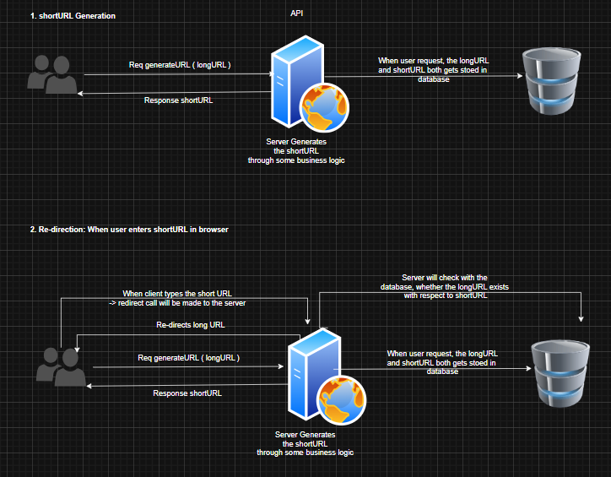
5.Low Level Design (LLD):-

Approach 01: Hashing (Encryption)

Method: shortURL = encrypt(longURL)
Algorithms: MD5, SHA-1, Base64
Problems:
- Long hash length (not short).
- High collision probability.
- Multiple DB lookups.
- High latency at scale. Not suitable for large-scale systems
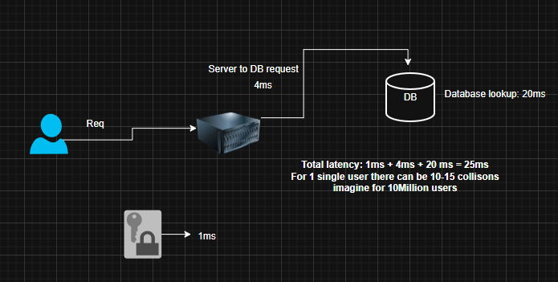
Approach 02: Counter-Based Approach (Recommended)
Logic:
- Generate a global counter value.
- Convert counter to Base62.
- Use Base62 value as short URL.
Example:
Counter = 10000
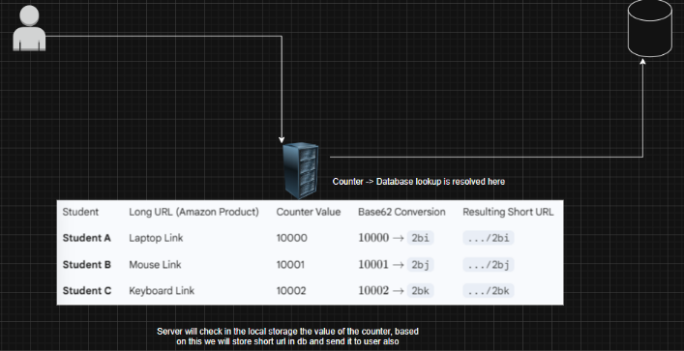
Base62 = 2bi
Short URL = short.ly/2bi
Advantages
- No collision
- Fast generation
- Predictable length

Scaling Challenges & Solutions
Problem 1: Monolithic Server
- Cannot handle 100M users
Solution: Horizontal Scaling (Multiple Servers)
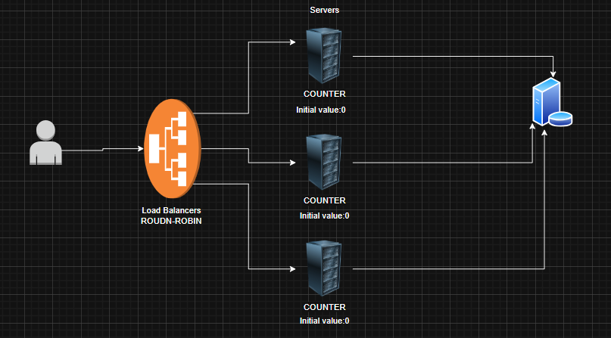
Problem 2: Distributed Counter Conflict
- Multiple servers may generate same counter.
Solution:
Use Global Counter in Cache (Redis) with atomic increment.

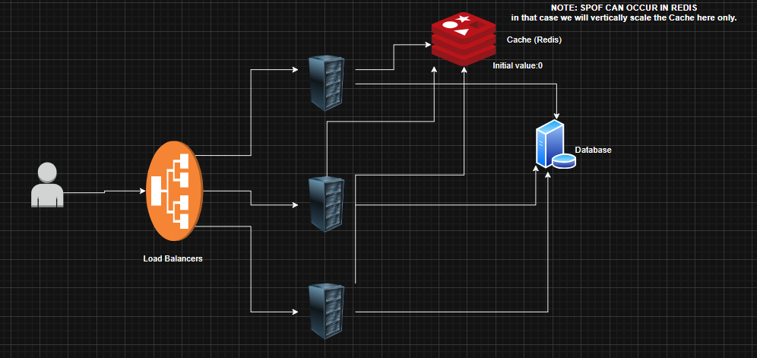

Type of Database Used
Recommended
- NoSQL (Key-Value Store)
- Redis (Cache)
- DynamoDB / Cassandra (Persistent)
Reason:
- Fast read/write
- High availability
- Easy horizontal scaling

Type of Server
- Stateless REST API Server • Deployed behind Load Balancer
- Performs:
  - URL validation
  - Counter fetch
  - Base62 conversion
  - DB read/write

Steps to Do Experiment

Step 1: Set Up the Project
bash
mkdir url-shortener && cd url-shortener
python -m venv venv
source venv/bin/activate # On Windows: venv\Scripts\activate
pip install flask

Step 2: Write the URL Shortener Code
Create a file app.py:

python
from flask import Flask, redirect, request, jsonify
import hashlib
import time
import threading
from collections import defaultdict

app = Flask(__name__)
url_map = {}
metrics = {'total_requests': 0, 'latencies': []}

def generate_short_code(long_url):
return hashlib.md5(long_url.encode()).hexdigest()[:8]

@app.route('/shorten', methods=['POST'])
def shorten():
start_time = time.time()
long_url = request.json.get('url')
short_code = generate_short_code(long_url)
url_map[short_code] = long_url
latency = time.time() - start_time
metrics['latencies'].append(latency)
metrics['total_requests'] += 1
return jsonify({'short_url': f'http://localhost:5000/{short_code}'})

@app.route('/<short_code>')
def redirect_url(short_code):
start_time = time.time()
long_url = url_map.get(short_code)
if long_url:
latency = time.time() - start_time
metrics['latencies'].append(latency)
metrics['total_requests'] += 1
return redirect(long_url, code=302)
return 'URL not found', 404

@app.route('/metrics')
def get_metrics():
if metrics['latencies']:
avg_latency = sum(metrics['latencies']) / len(metrics['latencies'])
throughput = metrics['total_requests'] / (time.time() - app_start_time)
else:
avg_latency = throughput = 0
return jsonify({
'avg_latency_sec': avg_latency,
'throughput_req_per_sec': throughput,
'total_requests': metrics['total_requests']
})

def load_test(concurrent_users=10):
import requests
def worker():
requests.post('http://localhost:5000/shorten', json={'url': 'https://www.example.com/page?q=test'})
threads = [threading.Thread(target=worker) for _ in range(concurrent_users)]
for t in threads: t.start()
for t in threads: t.join()

if __name__ == '__main__':
app_start_time = time.time()
app.run(debug=True)
Step 3: Run the Server
bash
python app.py
Step 4: Test the Endpoints
Use Postman or curl to test:

POST to http://localhost:5000/shorten with JSON {"url": "https://www.example.com"}

GET to http://localhost:5000/<short_code> to redirect

GET to http://localhost:5000/metrics to see performance data

Step 5: Perform Load Testing
Modify the load_test() function to simulate different loads (10, 50, 100 users).

Run load tests and record metrics from /metrics endpoint.

Step 6: Record Observations
Create a table to compare latency and throughput for different loads.

Sample Input
json
{
"url": "https://www.google.com/search?q=system+design+course"
}
Sample Output
After shortening:
json
{
"short_url": "http://localhost:5000/a1b2c3d4"
}
Metrics after 100 requests with 10 concurrent users:
json
{
"avg_latency_sec": 0.012,
"throughput_req_per_sec": 45.7,
"total_requests": 100
}

RESULT:-
A scalable and highly available URL Shortener System was successfully designed using counter-based Base62 encoding, REST APIs, NoSQL database, and distributed architecture principles.

CONCLUSION:-
The counter-based approach with centralized atomic counters provides the most efficient, scalable, and collision-free solution for a URL Shortener system handling millions of users with low latency.

